Installation issues I encountered :

Could not activate virtual environment in PowerShell due to permission restrictions.

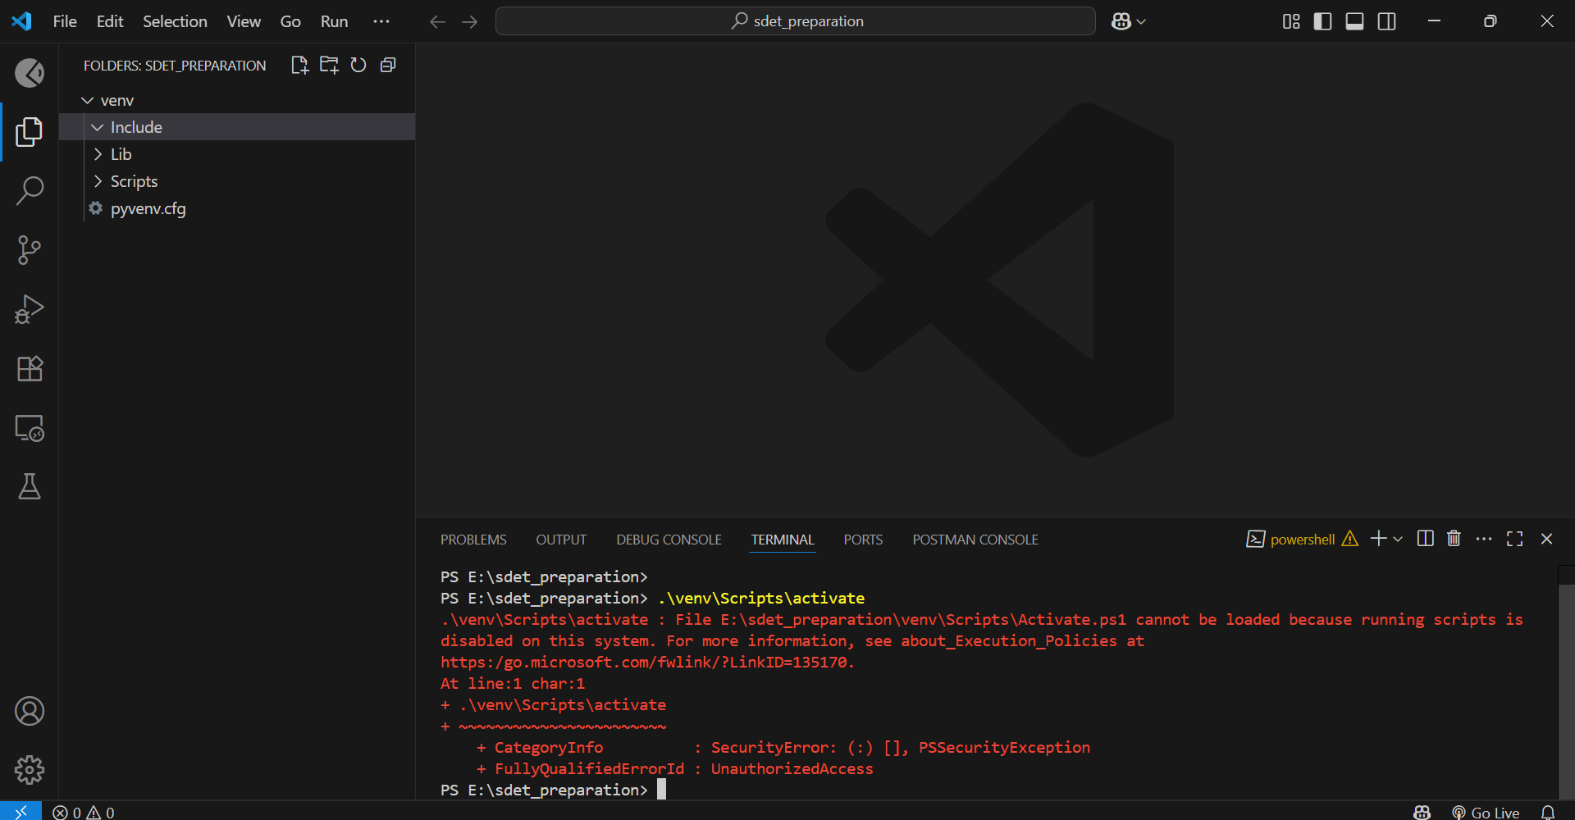

Solution:

Opened PowerShell as Administrator and set the execution policy then I was able to activate the virtual envrionemnet